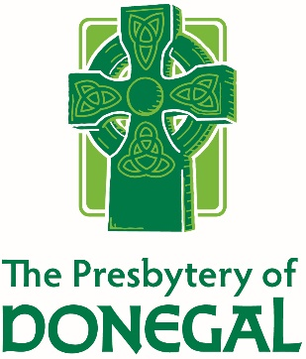
Request to be a Member-at-Large 2018

**Please Add Additional Pages If Needed
For the Following Information and Questions**

Date completed: ________________________

Name: _____________________________________________________________________________

Home Address: _______________________________________________________________________

Phone
Home:_______________________ Cell:______________________ Work:__________________

E-Mail Address: _______________________________________________________________________

The Book of Order states in G-2.0503b:
A member-at-large is a minister of the Word and Sacrament who has previously been engaged in a validated ministry, and who now, without intentional abandonment of the exercise of ministry, is no longer engaged in a ministry that complies with all the criteria in G-2.0503a. A minister of the Word and Sacrament may be designated a member-at-large because he or she is limited in his or her ability to engage in a ministry fulfilling all of the criteria for a validated ministry due to family responsibilities or other individual circumstances recognized by the presbytery. A member-at-large shall comply with as many of the criteria in G-2.0503a as possible and shall actively participate in the life of a congregation. A member-at-large is entitled to take part in the meetings of the presbytery and to speak, vote, and hold office. The status of member-at-large shall be reviewed annually.

- There are many reasons why a Minister of Word and Sacrament might request Member-at-Large Status. They include being “in between” positions, family responsibilities, health concerns, and being a supportive partner to an employed spouse. Please share the story of why you are requesting Member-at-Large status for 2018.

- Tell us about your connections to a congregation or a worshiping community.

- How are you able currently to exercise your Call as a Minister of Word and Sacrament in the PC(USA)?

- How are your skills and passions for ministry exercised in the mission and ministry of the Presbytery of Donegal? Are there ways you believe you are called to be connected and engaged?

- How is your life in general? How may COM and your colleagues pray for and support you? May we share your prayer concerns with the Presbytery?
- Do you intend to regularly attend Presbytery Meetings? If so, would you make use of a time set apart during a regularly scheduled Presbytery Meeting for those in Validated Ministries and Members-at-Large to gather briefly for Presbytery updates, an education event or fellowship with friends and colleagues?

- Would you like to also enter the process to be authorized for the Presbytery Pulpit Supply List? If so, we will be in touch with you separately about that. YES NO

Return by: January 12, 2018 To: Christine Wells, Executive Administrative Assistant
The Presbytery of Donegal, PO Box 10054, Lancaster, PA 17605-0054 or christine@donegalpby.org

