Rev. Dr. Erin Cox-Holmes Bio
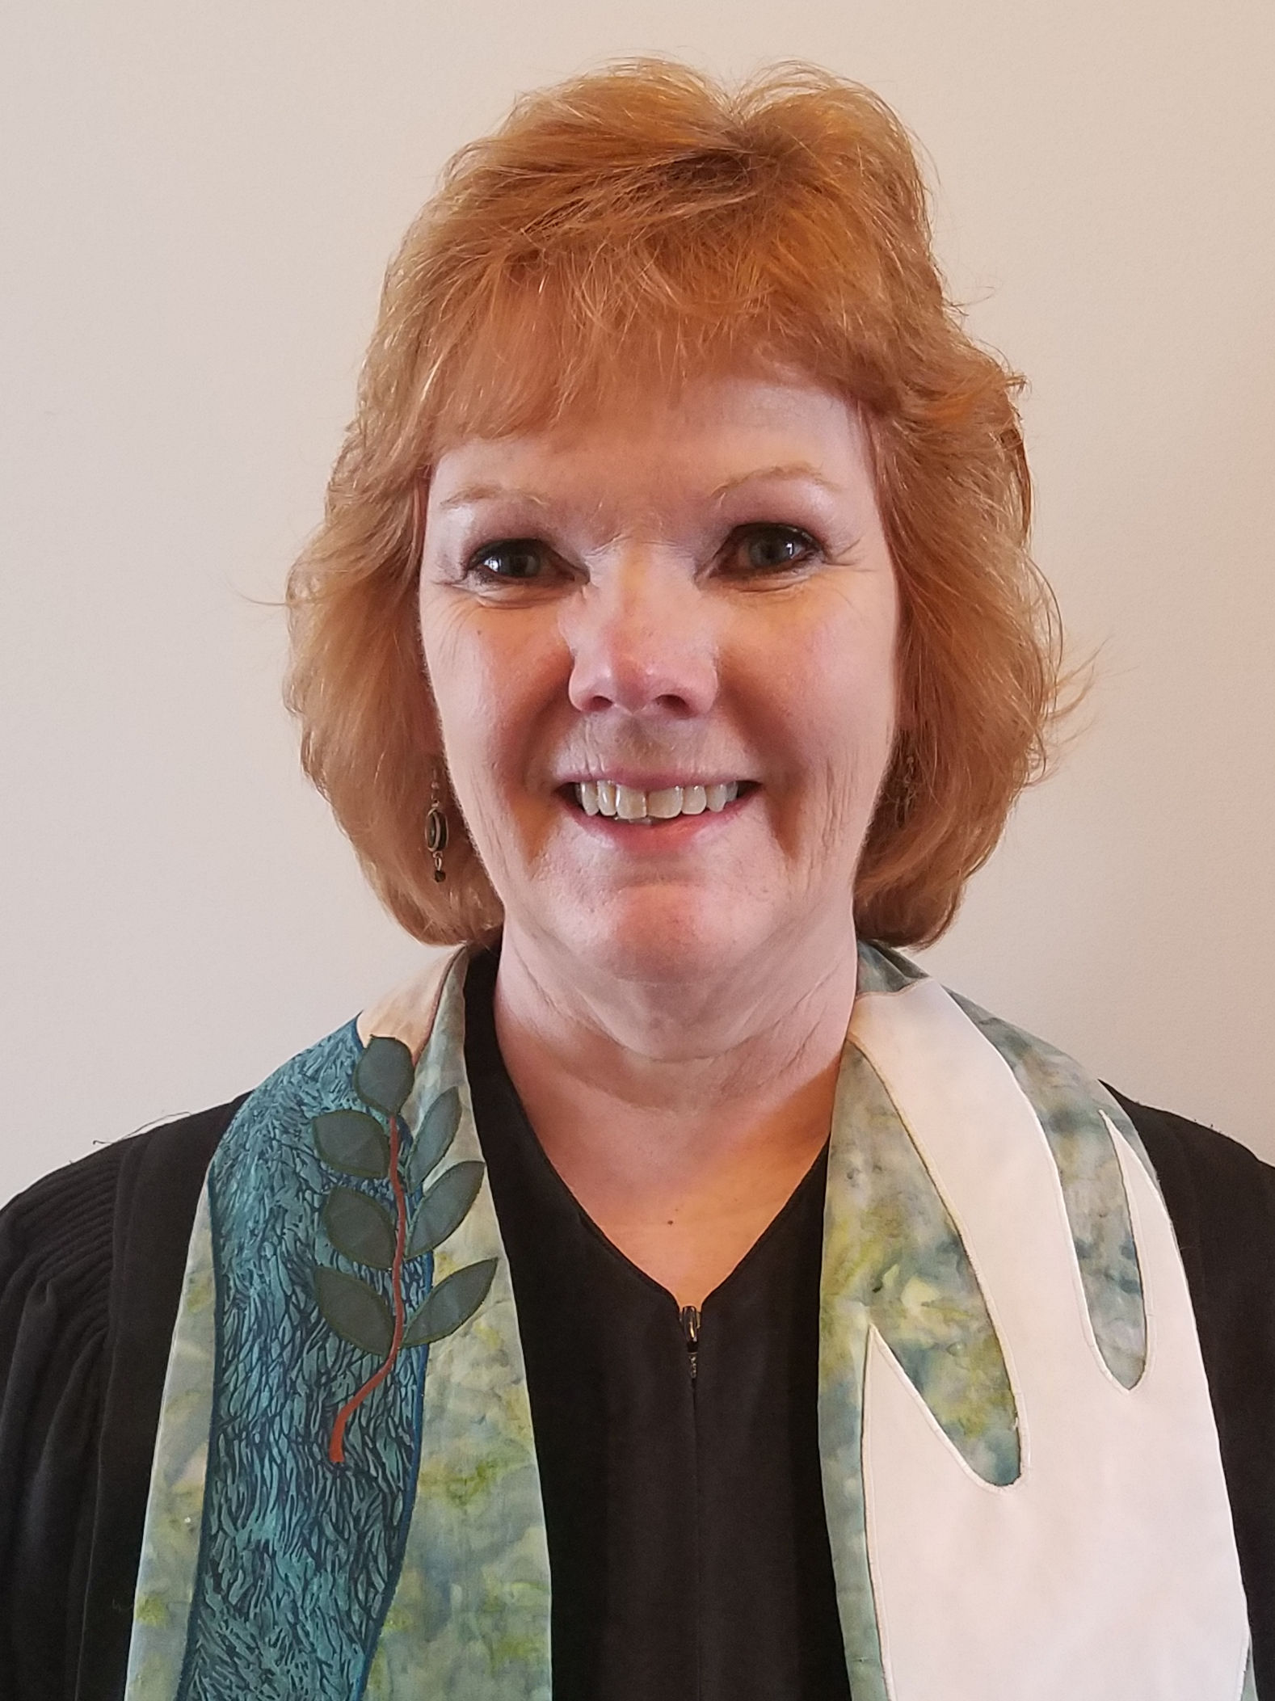
The Rev. Dr. Erin S. Cox-Holmes was raised in Redlands, California. She graduated from the University of Redlands in 1980 with a degree in English and Religion. She received her Master of Divinity from Earlham School of Religion, and was ordained in the Presbytery of Detroit. After service as an associate pastor and an interim pastor, Erin served for 15 years as the Associate Executive Presbyter in Kiskiminetas Presbytery in western Pennsylvania. She received her Doctor of Ministry from Dubuque Theological Seminary in 2008, with a focus on revitalizing the church and worship in the digital age. She began as the Executive Presbyter in Donegal Presbytery on January 1 of 2010. Erin's husband, the Rev. Kent Holmes, is serving Bethany Presbyterian Church as pastor, after 18 years as the pastor of Punxsutawney Presbyterian church. They live in Manheim Township north of Lancaster. Daughter Meredith is a senior at Elizabethtown College this fall. Son Graham is employed as a therapist in Lancaster. Erin and Kent love travel, movies, walks on trails beside water. Erin is known as a computer geek, and has been puzzling over the same ee cummings poem for 30 years.

